EX NO: 1b: CHARACTERISTICS STUDY OF SIDE BAND POWER AND
FREQUENCIES IN AM USING MATLAB

Objectives:
i) To generate an Amplitude Modulated (AM) signal in MATLAB using specified carrier and
modulating signal parameters.
ii) To determine and verify the upper sideband (USB) and lower sideband (LSB) frequencies of
the AM signal using frequency spectrum analysis in MATLAB.
iii) To calculate the carrier power, sideband power, and total transmitted power of the AM signal
for a given modulation index using MATLAB.
iv) To analyze the effect of varying the modulation index on sideband power distribution and
overall transmission efficiency through MATLAB simulation.

PROGRAM (MATLAB CODE):
clc;
clear;
close all;
Am=1;
fm=500;
Ac=5;
fc=5000;
fs=20*fc;
t=0:1/fs:4/fm;
m = Am*sin(2*pi*fm*t);
c = Ac*sin(2*pi*fc*t);
mu = Am/Ac;
am = Ac*(1+mu*sin(2*pi*fm*t)).*sin(2*pi*fc*t);
dem = abs(hilbert(am)); dem = dem-mean(dem);
N=length(am); f=linspace(-fs/2,fs/2,N);
AM_FFT=abs(fftshift(fft(am)))/N;
USB=fc+fm; LSB=fc-fm;
Pc=Ac^2/2; Psb=(mu^2*Pc)/4;
figure('Name','AM Modulation','NumberTitle','off');

subplot(3,2,1), plot(t,m), title('Message'), grid on
subplot(3,2,2), plot(t,c), title('Carrier'), grid on
subplot(3,2,3), plot(t,am), title('AM Signal'), grid on
subplot(3,2,4), plot(t,dem), title('Demodulated'), grid on
subplot(3,2,5), plot(f,AM_FFT), xlim([fc-3*fm fc+3*fm]), title('Sidebands'), grid on
subplot(3,2,6), bar([Pc Psb Psb]), set(gca,'XTickLabel',{'Carrier','USB','LSB'}),
title('Power'), grid on
fprintf('μ=%.2f | USB=%d Hz | LSB=%d Hz | Pc=%.2f W | Psb=%.3f
W\n',mu,USB,LSB,Pc,Psb);

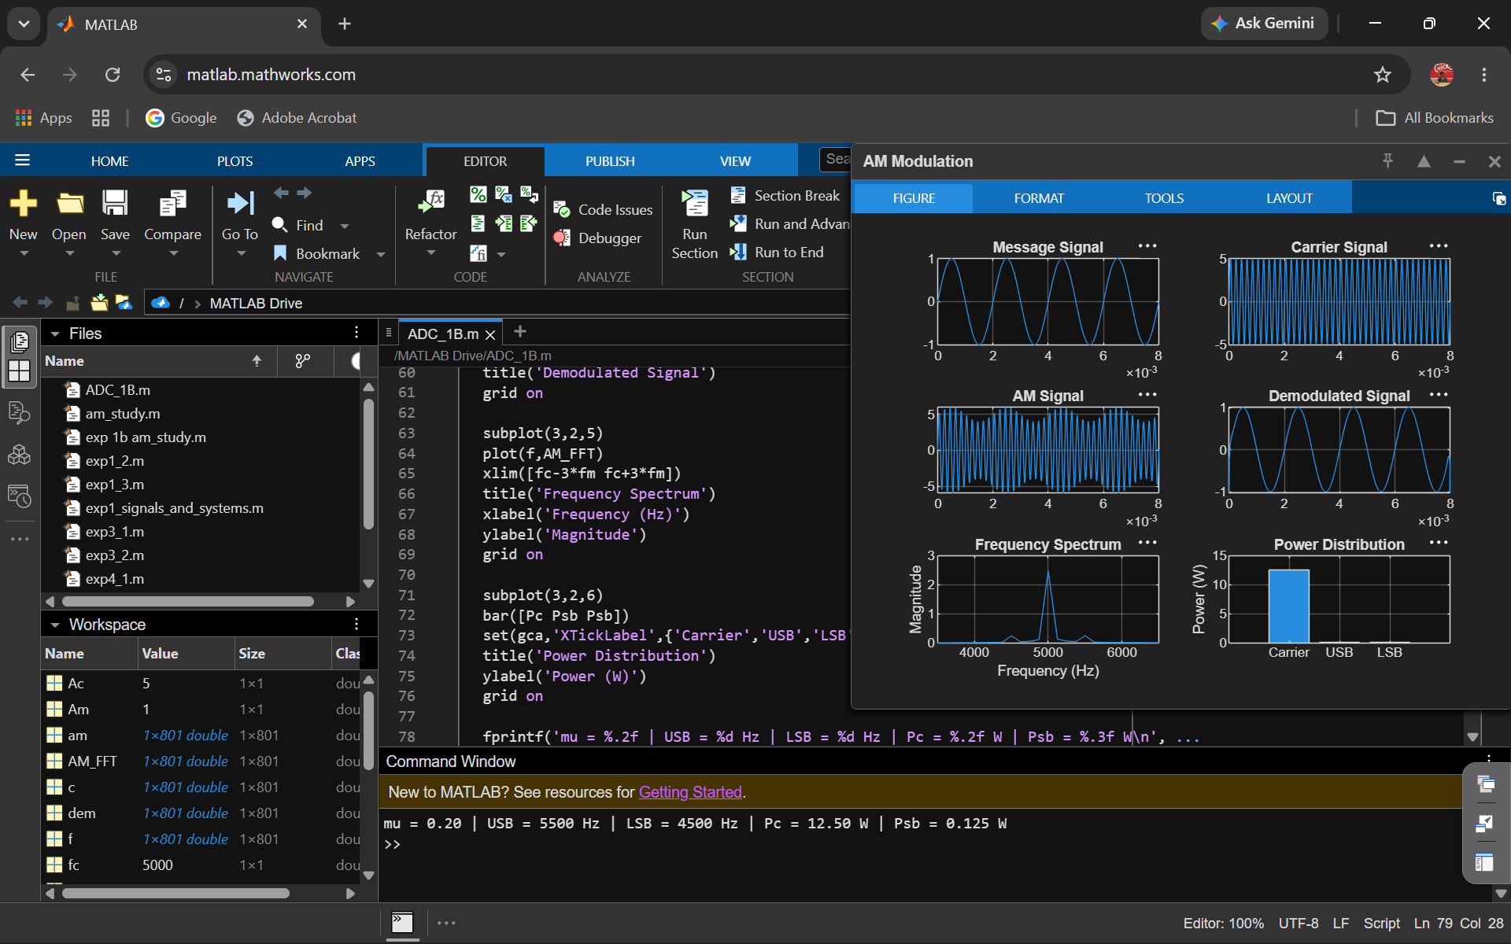
Output:

